Company Mailer Project

Submitted to :- Sachin Sir

By :- Vivek Jhaniya

**Objective/ Vision**

A mailer application for a company that can be used by the employees of the company only. It can be run on intranet. Each user can send mails, receive mails and delete mails after getting logged in!

**Users of the System**

1. User
2. Admin

**Functional Requirements**

**1. User**

1. Can register
2. Can login and logout
3. Can send mails
4. Can see inbox
5. Can see sent mails
6. Can see trash
7. Can search other employees email id
8. Can view and update profile

**2. Admin**

1. Can unauthorize the user
2. can see current logged in members

**Non-Functional Requirements**

1. Secure access of confidential data (users details). SSL can be used.
2. 24 X 7 availability
3. Browser testing and support for IE, NN, Mozila, and Firefox
4. Reports exportable in .XLS, .PDF
5. Create a detailed UML diagram (Component, Sequence, Class) for the system and its sub-components

**Tools to be used**

1. Eclipse neon 3.0 IDE
2. MySQL 8.0
3. Server: Apache Tomcat

**Front End and Back End**

1. **Front End:** Servlet, HTML, CSS
2. **Back End:** MySQL

Index

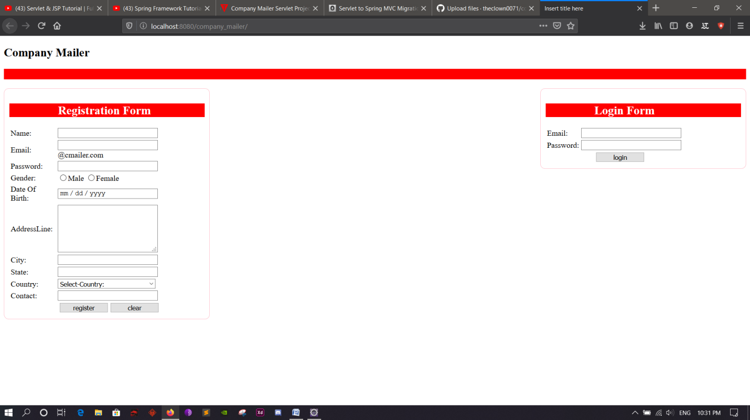

Data Flow Diagram

